# Business Challenge

# Providing enterprises for a new way to engage their consumers and fulfill their requests. Also provide consumers with timely and relevant information/answers to queries/questions, while keeping costs in line with budgets is a huge challenge for enterprises. This can lead to customer dissatisfaction and impact enterprises adversely.

# Watson inspired solution to the problem

Today we can leverage the Watson Platform to directly engage with customers over a variety of channels like chat, IVR, social media etc. Watson will answer customer inquiries, fulfill their intents or triage them to the right agents within the enterprise to address the inquiries. This solution pattern is applicable to multiple industries where there is high call volume namely *Telecommunications, Airline, Financial Services, Retailers and Media companies.*

# Client discussion points

* Can you respond to inquiries in a timely manner, 24X7?
* Are you answering customer inquiries in the channel you receive them with a high degree of accuracy, the first time?
* Can you deliver tailored conversational interactions that are relevant and engaging regardless of channel?
* Do you have a UI and channels that allow client interactions in place?
* Do you want to build conversational bots that can allow customers to interact with you from their channel of choice (Facebook, Twitter, etc.)?

# Qualification Checklist

* Are we engaged with Chief Services Officer or the Chief Digital Officer?
* Does the client have $250K to get started?
* Will the organization adopt Watson using their resources for development or do they need IBM Professional Services?
* What are the channels that the customer has adopted?
* How many interactions are handled yearly by the contact center, with what velocities are they handled without human intervention?

# Elevator pitch

What is the client buying

* A one year subscription to Watson Developer Cloud Platform enabling the client to develop a Conversation BOT solution

How much does it generally cost and timeline?

* $250K for 1 year & 4 weeks to deploy an initial pilot

How does the solution get implemented?

* Self-Serve: 1-week enablement session for client developers with education on the solution pattern. After which, client IT teams then develop/deploy the solution in a self-serve mode.
* Professional Services: Leverage IBM or a systems integrator to develop

# r pitch

**What is the client buying**

* A one year subscription to Watson Developer Cloud Platform enabling the client to develop the Field Technician pattern

**How much does it generally cost and timeline?**

* $250K for 1 year & 4 weeks to deploy an initial pilot

**How does the solution get implemented?**

* There are two options:
* Self-Serve: 1-week enablement session for client developers with education on the solution pattern. After which, client IT teams then develop/deploy the solution in a self-serve mode.
* Professional Services: Hire system integrator to develop

# Elevator pitch

**What is the client buying?**

* A subscription to Watson Developer Cloud Platform which will enable the client to develop the Social CRM pattern

**How much does it generally cost and timeline?**

* $250K for 1 year & 4 weeks to deploy an initial pilot

**How does the solution get implemented?**

* There are two options:
* Self-Serve: 1-week enablement session for client developers with education on the solution pattern. After which, client IT teams then develop/deploy the solution in a self-serve mode.
* Professional Services: Hire system integrator to develop

# Video Demo

[Conversation BOT demo - Best Buy](https://ibm.box.com/s/tx7xzgtsdhvpulhsb2x5cov2zyhbuu26)

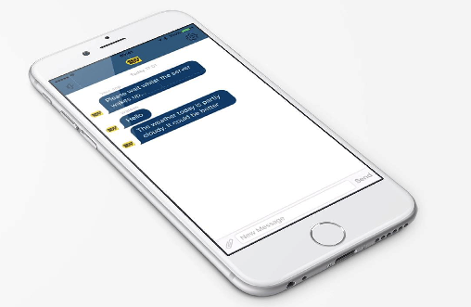

# KPI’s impacted

* Increase Contact Deflection
* Net Promoter Score (NPS)
* Warm handoff to decrease AHT

# Target Buyer

* Chief Digital Officer
* Chief Experience Officer (CXO)
* Digital Experience Manager

## Competitive Differentiation

* Industry leading Watson APIs and platform
* A system that incorporates existing client systems, Q&A, process workflows, machine learning and emerging cognitive API’s on a platform into a singular engaging customer experience.
* Provide a tailored experience with personalized advice and recommendations in a proactive manner
* Dashboard view for reporting and identifying inadequacies in the channel for process tuning

|  |  |  |
| --- | --- | --- |
| Conversation BOT |  | Contact – Owen Coelho – occoelho@us.ibm.com |